Zomato Data Analysis By Excel

I conducted a data analysis project on Zomato 2022 data.

Dataset Source – <https://www.kaggle.com/datasets>

Tools Used – Microsoft Excel.

Requirement Gathering:

* Requirement Gathering (Firstly , I understood the data in the data sets and find the business problems)
* And Clearly define the purpose of this data analysis.

Data Cleaning:

* Remove the duplicates and irrelevant data.
* Handled missing values by either filling them in or removing rows/columns with missing data.
* Formatting the data consistently and Verify the data accuracy and correct any errors.

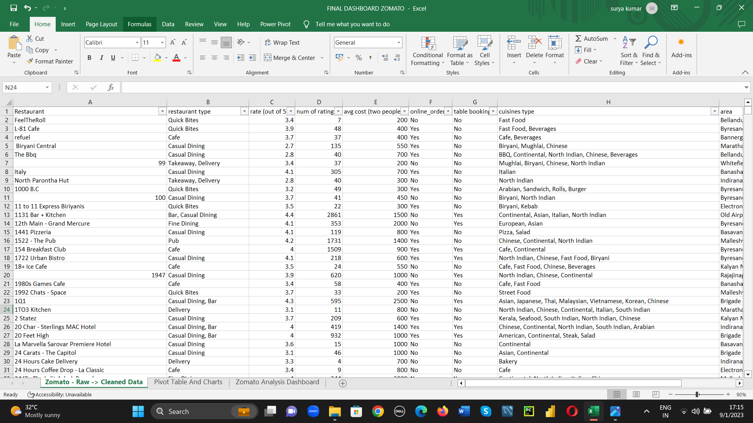

Data Exploration:

* Explored the cleaned data to understand its characteristics:
  + Calculate basic statistics (mean, median, variance).
  + Create simple charts (histograms, bar charts, scatter plots) to visualize the data.

Data Transformation:

* Performed the data aggregations.
* Filter and sort the data to focus on specific subsets.

Data Analysis:

* Utilize Excel's functions, formulas, and pivot tables to answer the questions or uncover insights.
* Conduct trend analysis, correlations, and statistical tests, as appropriate

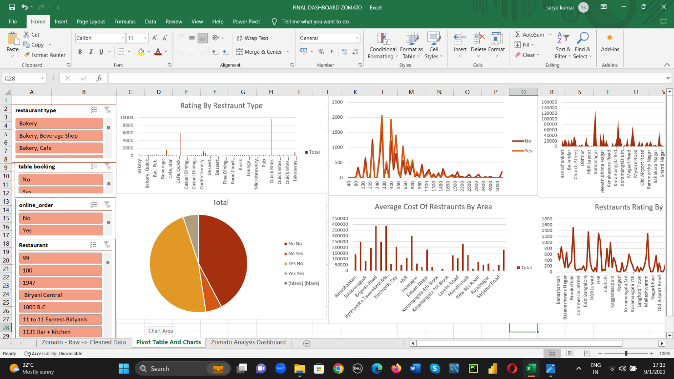

Data Visualizations:

* Finally ,I built a dashboard in Excel with slicers so that users can interact with the dashboard and view it in different ways to get results.
* Build meaningful charts and graphs to present the findings.
* Various chart types like bar charts, line charts, pie charts, and more.
* Used color and labels effectively to make this visualizations clear and informative.

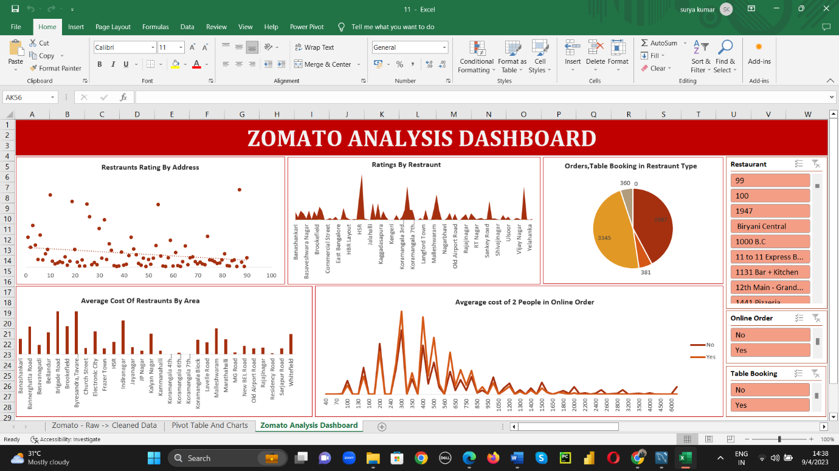

Insights:

* Restaurants Ratings by Address
* Average cost of Restaurants by Area
* Ratings by Restaurants.
* Average cost of 2 people in Online order
* Online and Table booking by Restaurant type

